Name__no name= deduction of 5 points______
STAT 200 Midterm Exam
20 Questions (5 points each)
Instructions: Show your work! Round all decimals to the hundredths place. If numbers are small, then round to 4 decimal places. If no work or calculator steps are shown, no credit will be given for correct answers. Include units and proper notation as needed to get full credit for answers (ex: P(x) for probability, μ for population mean, and σ for population standard deviation). If you are typing in Word, you can find these symbols in the Insert tab under Symbols. Remember appropriate titles and labels for graphs.
Submit your midterm as a single PDF file. Sign and date at the bottom of the exam.
1.1.2
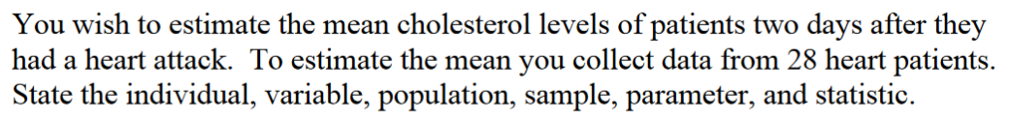

1.1.10
State the measurement scale for each.
- Temperature in degrees Celsius

- Ice cream flavors available

- Pain levels on a scale from 1 to 10, 10 being the worst pain ever

- Salary of employees

1.2.6
Consider making a numbered or bulleted list of steps.
1.4.3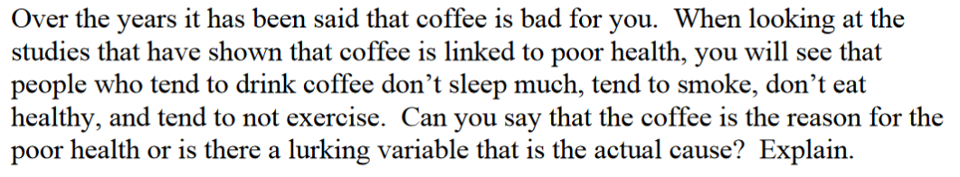

2.1.1
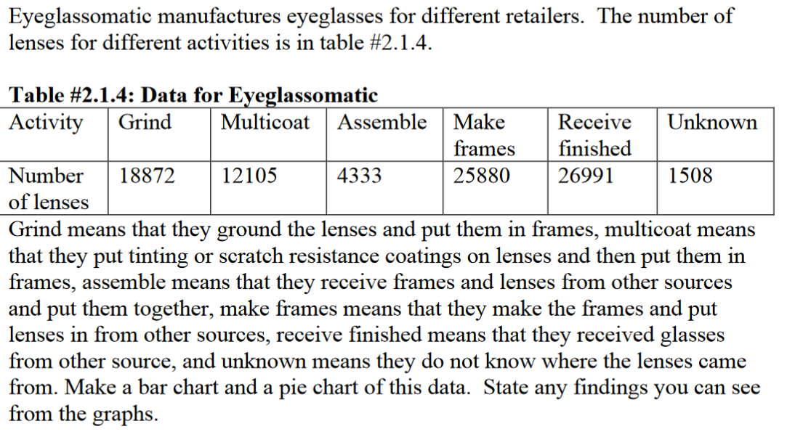

2.1.7
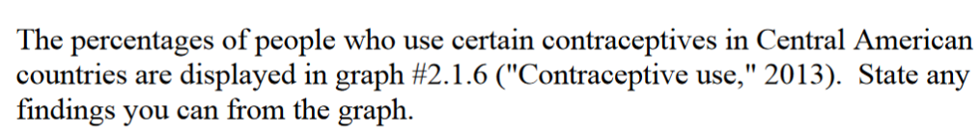
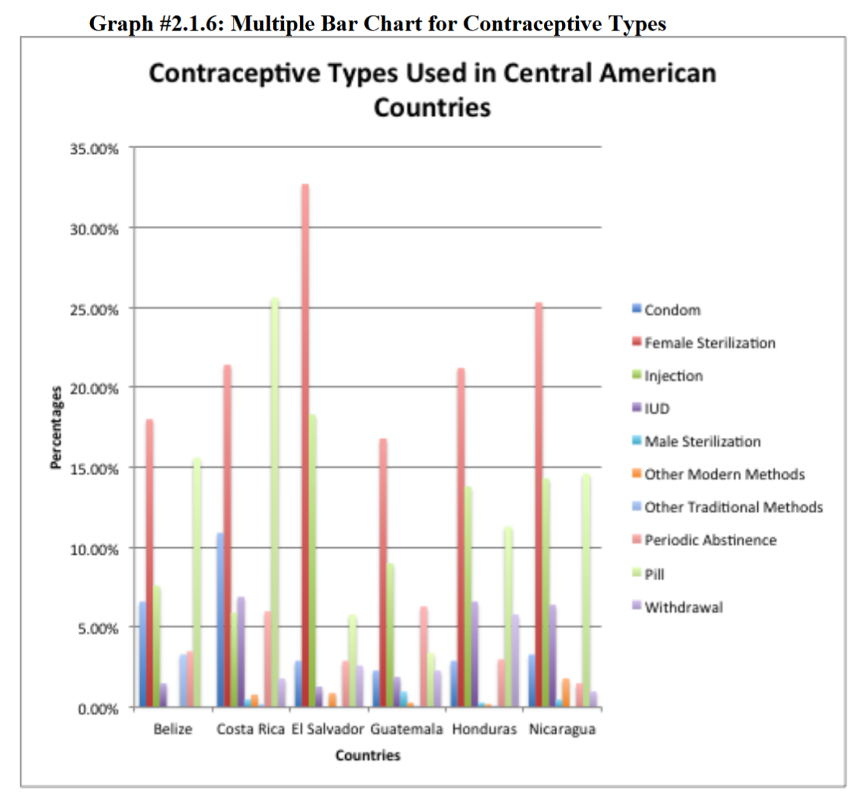

2.2.4
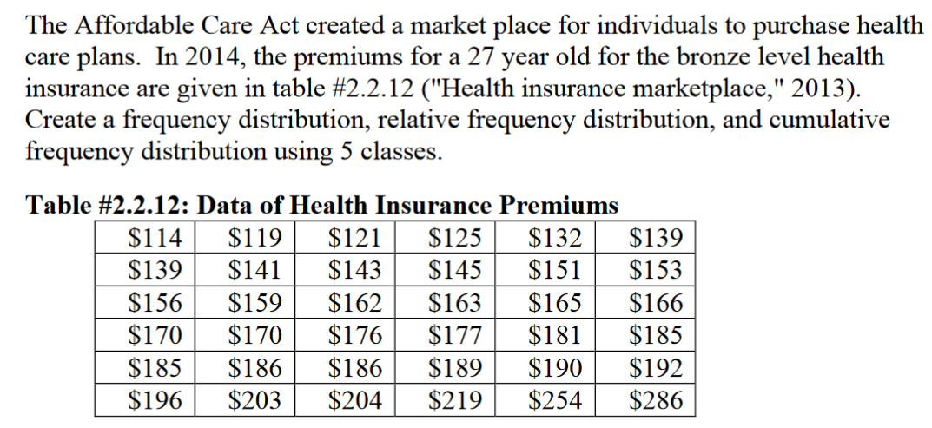
2.3.5
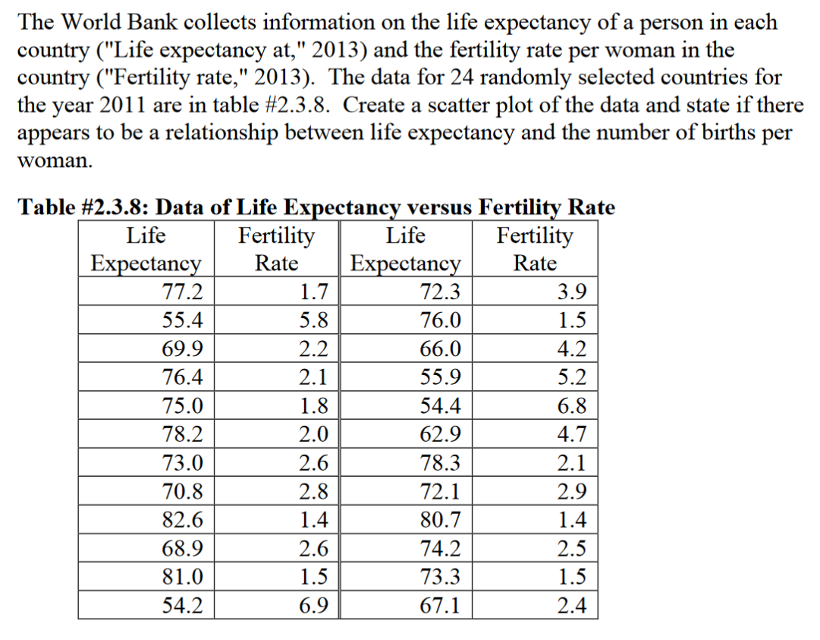
3.1.13
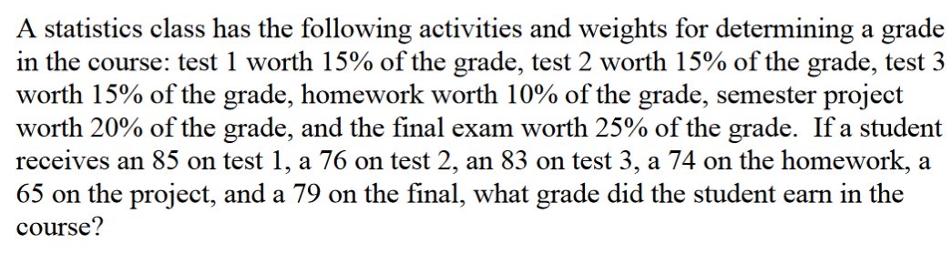
3.2.4
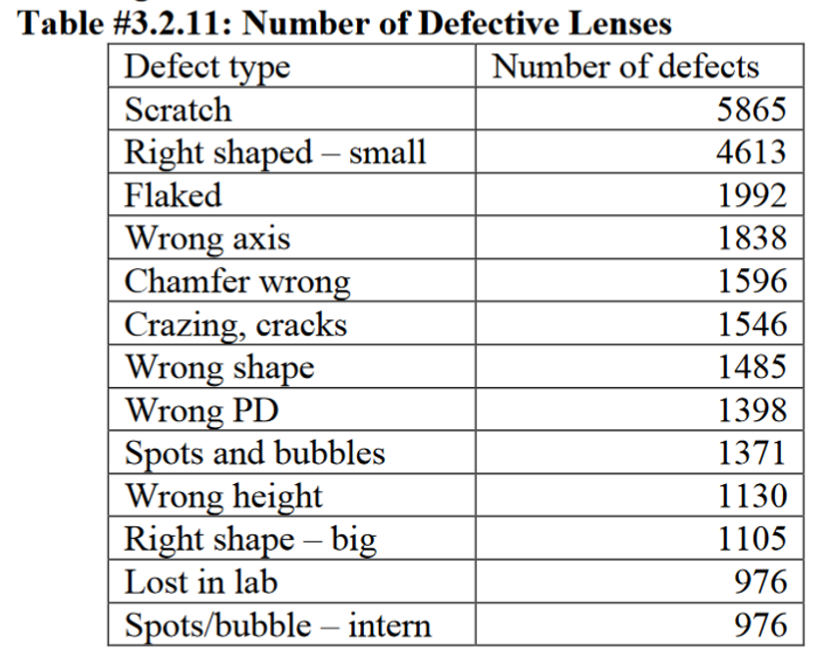
- Find the mean and median.
- Find the range.
- Find the variance and standard deviation.

4.2.1
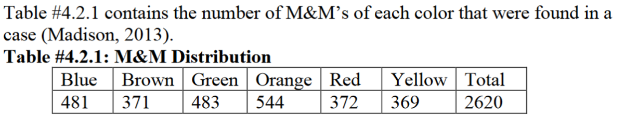
- Find the probability of choosing a green or red M&M.
- Find the probability of choosing a blue, red, or yellow M&M.
- Find the probability of not choosing a brown M&M.
- Find the probability of not choosing a green M&M.

4.3.10

5.1.1
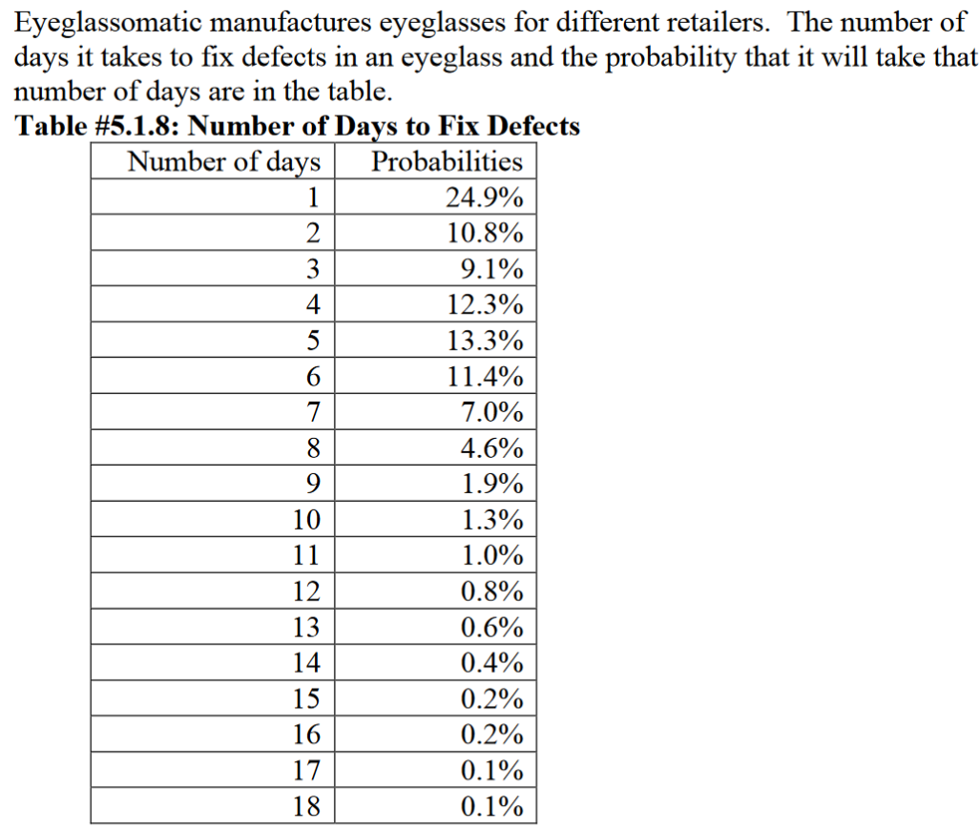
- State the random variable.
- Draw a histogram of the number of days to fix defects.
- Find the mean number of days to fix defects.
- Find the variance for the number of day to fix defects.
- Find the standard deviation for the number of days to fix defects.
- Find the probability that a lens will take at least 16 days to make a fix the defect.
- Is it unusual for a lens to take 16 days to fix a defect?
- If it does take 16 days for eyeglasses to be repaired, what would you think?

5.2.6
- P(x = 21)
- P(x = 6)
- P(x = 12)
- P(x ≤ 14)
- P(x ≥ 17)
- P(x ≤ 9)

5.2.7
- State the random variable.
- Argue that this is a binomial experiment.
Find the probability that
- None are left-handed.
- Seven are left-handed.
- At least two are left-handed.
- At most three are left-handed.
- At least seven are left-handed.
- Seven of the last 15 US Presidents are left-handed. Is this unusual? What does that tell you?

5.3.5
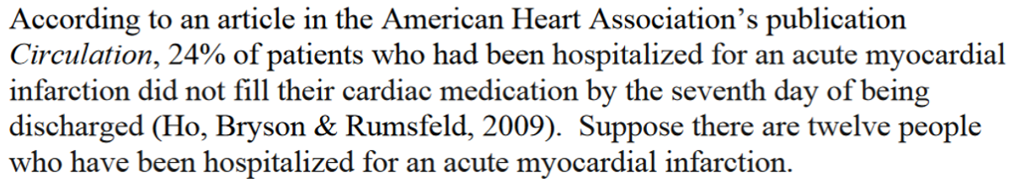
- State the random variable.
- Write the probability distribution.
- Draw a histogram.
- Describe the shape of the histogram.
- Find the mean.
- Find the variance.
- Find the standard deviation.

6.1.1
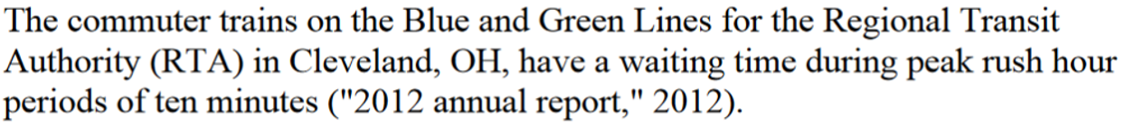
- State the random variable.
- Find the probability of waiting between two and five minutes.
- Find the probability of waiting between seven and ten minutes.
- Find the probability of waiting eight minutes exactly.

6.3.5
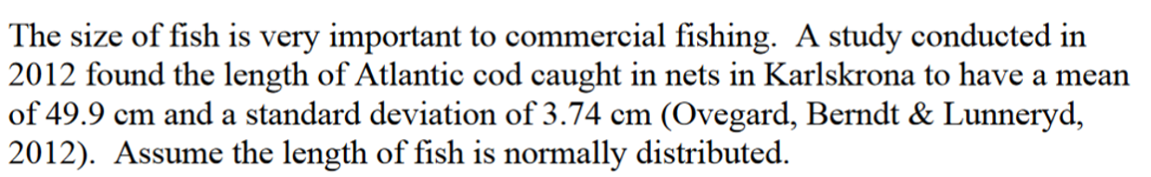
- State the random variable.
- Find the probability that an Atlantic cod has a length less than 52 cm.
- Find the probability that an Atlantic cod has a length of more than 74 cm.
- Find the probability that an Atlantic cod has a length between 40.5 and 57.5 cm.
- If you found an Atlantic cod to have a length of more than 74 cm, what could you conclude?
- What length are 15% of all Atlantic cod longer than?

6.4.1
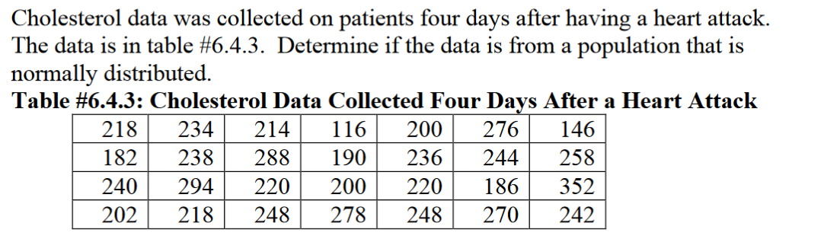

6.5.3
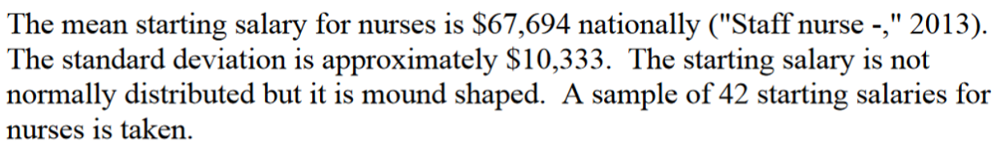
- State the random variable.
- What is the mean of the sample mean?
- What is the standard deviation of the sample mean?
- What is the shape of the sampling distribution of the sample mean? Why?
- Find the probability that the sample mean is more than $75,000.
- Find the probability that the sample mean is less than $60,000.
- If you did find a sample mean of more than $75,000 would you find that unusual? What could you conclude?

I have completed this exam myself, working independently and not consulting anyone except the instructor. I have neither given nor received help on this exam. Leaving the information below blank will result in a grade of zero for your midterm exam.

Name:____________________________________ Date: ________________________

Signature: ________________________________

